Aviso de Ofrecimiento de Empleo
Parte Oral: Junto con el aviso de ofrecimiento de empleo se encuentran algunas preguntas modelo, sin embargo, puede pedírsele al alumno responder otras preguntas sobre el aviso, también se le puede pedir más ejemplos, tanto de requisitos como de ofrecimientos, también se le puede solicitar explicar o fundamentar su respuesta.
MECATRÓNICA
- Describa los aspectos de la misión de la empresa la hacen atractiva a usted como postulante
- De los requisitos para acceder al empleo ofrecido:
- Indique 3 requisitos que cumpla o tareas para las cuales esté ya preparado.
- Indique 3 requisitos que todavía no cumpla o tareas que todavía no puede realizar.
- Elija 3 aspectos o habilidades que le parece que cumple
- Seleccione 3 requisitos que le parezca que son más difíciles de cumplir.
- Diga 3 aspectos de la descripción del empleo que considere valiosos.

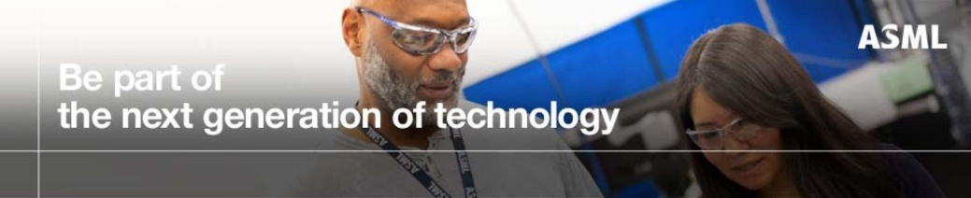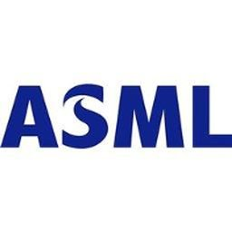

Mechatronics Engineer: Production First Line Support (CWW days)
ASML
Wilton, CT 06897

Job Mission
ASML is the world’s leading provider of lithography systems for the semiconductor industry, manufacturing complex machines that are critical to the production of integrated circuits or microchips. This position is for a First Line Support Production Engineer with innovative attitude to work in the Production Engineering department in Wilton Factory. Candidate will work with cross-sectors employees to provide rapid response to resolve disturbance notices related to engineering issues and to perform the engineering steps listed in the production operator dashboard (POD) to support output.
Job Description
- Spends about 75% of time in the Cleanroom providing direct support to production processes and troubleshooting
- Provide efficient response to troubleshoot electro-mechanical modules and subassemblies
- Provide efficient response to troubleshoot module test and final qual issues.
- Provide efficient response to troubleshoot multi-discipline test equipment (Hardware/Software/Electrical/Servo)
- Master test rig qualification software: Linux/Python + Proprietary ASML GUI
- Analyze MATLAB runs and plot data from database
- Support query code to interrogate data for manufacturing needs
- Support analysis on test data and derive conclusions
- Develop OCAPs, Fishbones and troubleshooting guidelines
- Support diagnostics qualification and implementation for production staff
- Evaluate and disposition failed parts with proposed solutions
- Support development of Manufacturing procedures and technical work instructions
- Support design and document reviews for diagnostics
- Support DOA root cause analysis
- Support cycle time and labor hours roadmaps implementation
- Support PFMEA.
- Able to read mechanical, electrical and optical drawings
- Knowledge of MATLAB, LabVIEW and Python
- The employee is willing to provide occasionally weekend coverage
- The employee is required to work in a cleanroom environment:
  - full gowning (full body coveralls, hood, CR safety shoes, face mask, nitrile gloves and safety glasses. Working under ISO 9000/14000 standards).
  - Working around overhead cranes, fork trucks and motorized pallet movers.
  - Working around lasers; working with ladders; working on platforms; and working around chemicals.

Education and experience
- Bachelor of Science in Mechatronics or Mechanical or Electrical or Computer or Software Engineering
- 2-5 years’ experience in an Engineering environment
- Must display a solid understanding of complicated manufacturing assemblies
- Working knowledge with servo and mechatronic control systems
- Working knowledge with complicated multi-disciplinary (Electro-Mechanical) assembly
- Working knowledge with integrated Hardware/Software testers
- Working knowledge of Unix/Linux/Python/Matlab
- Experience in a production environment with high tech products and complex production processes
- Working knowledge with Optical-Electrical sensors is a plus
- Experience in the field of technical Production Engineering and quality methodology such as statistical process control and FMEA is a plus
- Working knowledge of NX, Teamcenter and SAP is a plus
- Working knowledge with vacuum systems is a plus
- Working Knowledge in image/signal /data process algorithm, statistics and software development is a plus
Personal skills
- Capability to interface with multidisciplinary groups (including senior leadership), and be willing to take on responsibility and follow through
- Possess strong ownership characteristics – demonstrated commitment to achieving results on time
- Have strong written and oral communicative skills – ability to communicate effectively to your team and to senior management
- Focus on quality and continuous improvements
- Demonstrated “team player” with a quality orientation and interpersonal skills

Context of the position
The physical demands described here are representative of those that must be met by an employee to successfully perform the essential functions of this job. Reasonable accommodations may be made to enable individuals with disabilities to perform the essential functions.
- While performing the duties of this job, the employee routinely is required to sit; walk; talk; hear; use hands to keyboard, finger, handle, and feel; stoop, kneel, crouch, twist, reach, and stretch.
- The employee is occasionally required to move around the campus.
- The employee may occasionally lift and/or move up to 20 pounds.
- May require travel dependent on company needs.
- Specific vision abilities required by this job include close vision, color vision, peripheral vision, depth perception, and ability to adjust focus.
- Can work under deadlines.
- The environment generally is moderate in temperature and noise level.
- Must be able to read and interpret data, information, and documents.
- Can observe and respond to people and situations and interact with others encountered in the course of work.
- Can learn and apply new information or skills.
Other information
This position may require access to controlled technology as defined in the Export Administration Regulations (15 C.F.R. § 730, et seq.). Candidates must be legally authorized to access such controlled technology before employment. ASML may prioritize candidates immediately eligible to access controlled technology due to business needs.
This position requires access to controlled technology, as defined in the United States Export Administration Regulations (15 C.F.R. § 730, et seq.). Qualified candidates must be legally authorized to access such controlled technology prior to beginning work. Business demands may require ASML to proceed with candidates who are immediately eligible to access controlled technology.

Descripción completa del empleo
ASML US, LP brings together the most creative minds in science and technology to develop lithography machines that are key to producing faster, cheaper, more energy-efficient microchips. We design, develop, integrate, market and service these advanced machines, which enable our customers - the world’s leading chipmakers – to reduce the size and increase the functionality of their microchips, which in turn leads to smaller, more powerful consumer electronics. Our headquarters are in Veldhoven, the Netherlands, and we have 18 office locations around the United States including main offices in Wilton, CT, Chandler, AZ and San Jose, CA.

