Nuevo trabajo práctico 8
- Traduzca
- The design allows for the liquid to flow into the lower reservoir by gravity.
- There is a pressing need for the temperature to be monitored at every stage of the reaction.
- The experiment was designed for the particles to collide at sub-zero temperatures.
- The city ordinance requires the developer to include green spaces in the final architectural plan.
- The specifications ask the manufacturer to use only lead-free components in the assembly.
- It is important that these systems should be protected against data theft and manipulation.
- For the structural integrity to be maintained requires the stress at every point to remain below the yield strength.
- We demand that architects think about their role in spatial justice differently. We should be in the process of choosing what is going to get built as opposed to just designing what somebody else has preprogrammed.
- Society demands that information be instantaneously available.
- The specification provides for the contractor to supply all necessary specialized tools.
- We need powerful tiny batteries to unlock the full potential of microscale devices.
- Using thin-film technology in nuclear clocks is commensurate with semiconductors and photonic integrated circuits, suggesting that future nuclear clocks could be more accessible and scalable.
- Traduzca el texto y luego responda las preguntas
A universal strategy towards self-healing materials via dynamic interfacial liquid metal coordination
- Published: 16 February 2026
A universal strategy towards self-healing materials via dynamic interfacial liquid metal coordination
Results
Gallium is not suitable for use in metal-ligand coordination based self-healing polymers because of its weak metal coordination ability. Interestingly, liquid metal Ga acts as a metal solvent. This property allows the synthesis of coordination-active mLMs through the incorporation of metals such as silver (Ag), copper (Cu), and zinc (Zn). As shown in Fig. 1A, the introduction of mLMs into the polymer system resulted in successful interfacial coordination between the active metal atoms on the surface of the mLMs and the ligands on the polymer chains. Unlike a common metal-ligand coordination system, this interfacial coordination occurs exclusively around the active metal atoms on the surface of the fluidic mLMs. The fluidity of mLMs plays a critical role in the reversible interfacial coordination for self-healing involving mLMs and polymer materials. Figure 1B illustrates the self-healing process of interfacial coordination. Firstly, interfacial coordination is formed between the active metal atoms on the surface of mLMs and ligands (Fig. 1B₁). When damaged by external force, defective regions are generated on the surface of mLMs, and the interfacial coordination formed between mLMs and ligands is simultaneously damaged (Fig. 1B₂). Then, due to the fluidity of mLMs, the newly generated active metal atoms and Ga in the defective region migrate to the surface and heal the defects. The healed mLMs surface re-engages with the ligands on the polymer chains, thereby enabling the self-healing features (Fig. 1B₃). In contrast, realizing the self-healing capability by common strong metal coordination systems (such as Ag-S) is challenging, as demonstrated in Fig. 1C. Owing to the abundant active sites on Ag powder, strong Ag-S coordination bonds form between the powder and sulfur ligands in natural rubber (NR), creating a rigid network. The permanent and irreversible nature of the coordination bond at the interface makes it difficult for the composite to exhibit self-healing properties.
Fig. 1: Self-healing mechanisms by dynamic interfacial coordination of mLMs.
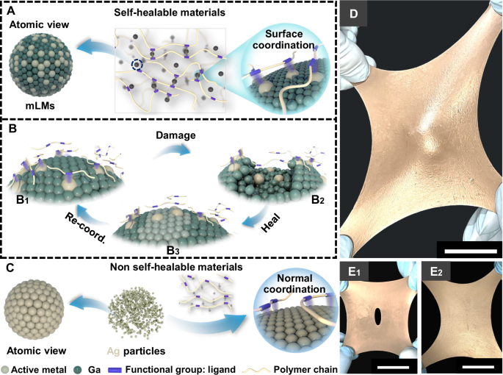
- ¿Qué característica específica del galio líquido permite que se puedan sintetizar mLMs mediante la incorporación de metales como la plata o el cobre?
- Describa brevemente qué ocurre en la superficie de los mLMs cuando el material sufre un daño por una fuerza externa.
- ¿Cuál es la razón principal por la cual la fluidez de los mLMs es considerada un factor crítico para las propiedades de autorreparación?
- Según el último párrafo, ¿qué propiedad de los enlaces de coordinación en el sistema de polvo de plata (Ag-S) hace que sea difícil que el compuesto exhiba capacidades de autorreparación?

