ORAL EXAM
CARDS

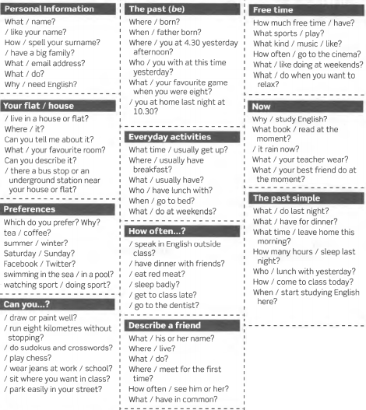

SITUATIONS
AT A CLOTHES SHOP
You are a customer. Student A is a shop assistant and starts the conversation. You:
- Ask if the shop has any trousers.
- Ask how much the trousers are.
- Pay.
- Say thank you and goodbye.

AT A CLOTHES SHOP
You are a shop assistant. Student B is your customer. Create a conversation in which you:
- Say hello and offer to help.
- Say where the trousers are.
- The trousers are £24.99.
- Ask if that is everything.

ARRANGING A MEETING
Student A calls you to go for a coffee. Accept his offer and ask her/him the place and time of the meeting. Ask her/him how to get to the place.

ARRANGING A MEETING
You are Student A and you call Student B to go for a coffee. Tell her/him where and when you can have the coffee. Explain her/him how to get to the place and the bus that takes her/him there.

ROOMS AND FURNITURE
Your best friend and you plan to go on holidays to Chile very soon. She/ He calls to tell you about a flat you can rent. Make questions about the following aspects:
- Where the flat is located
- Rooms: quantity, space
- Facilities
- Price
Finish the conversation telling your friend your personal opinion about the flat.
BUYING COFFEE
You plan to go on holidays to Chile very soon with your best friend. Call your friend and tell her/him about a flat you want to rent. Be ready to answer your friend’s questions with the following information:
- Flat near the sea
- 2 small rooms, 1 bathroom and a kitchen
- Air conditioning but no TV
- Price: $20 per day

AT THE HOTEL
You arrive in London and go to the first hotel you can find in the city. Speak to the receptionist and ask her/him for a room. Also, give the following information to fill in a registration card:
- Full name
- Nationality
- Address
- Telephone number
- Nights in the hotel
- Payment: with cash

AT THE HOTEL
You are the receptionist of a hotel. A visitor comes to ask for a room. Explain that you have a single room available and ask her/him the following information to fill in a registration card:
- Full name
- Nationality
- Address
- Telephone number
- Nights in the hotel
- Payment: with cash or credit card

BUYING COFFEE
Person A is the client and person B the waiter/waitress.
Take part in a conversation buying something to eat and something to drink.
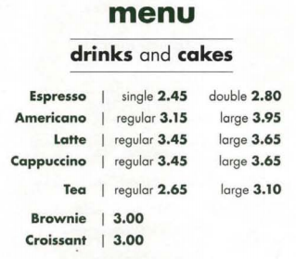
GOING SIGHTSEEING
Person A is at a hotel and he/she asks for directions a building (eg. the bank). Start with “Excuse me, where is ... ?
Person B gives directions.
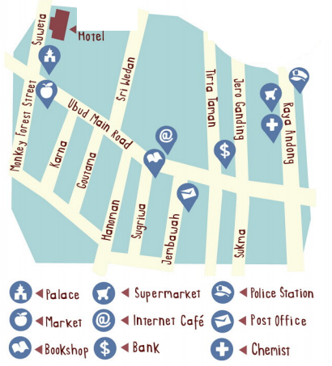

A MEMORABLE NIGHT N IN YOUR LIFE
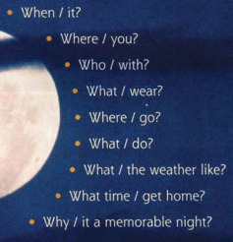
Name: |  |  | Date:
 | Content  (20 marks) | Structure – Organization  (30 marks) | Vocabulary  (30 marks) | Pronunciation  (20 marks)
PART 1
(3 cards: one for Present Simple, one for Present Continuous and 1 for Simple Past)
PART 2
(1 situation)
Final Score:

