VIDEO SESSION

- We’ll watch a video about different career paths for architects. But first let’s focus on important vocabulary.

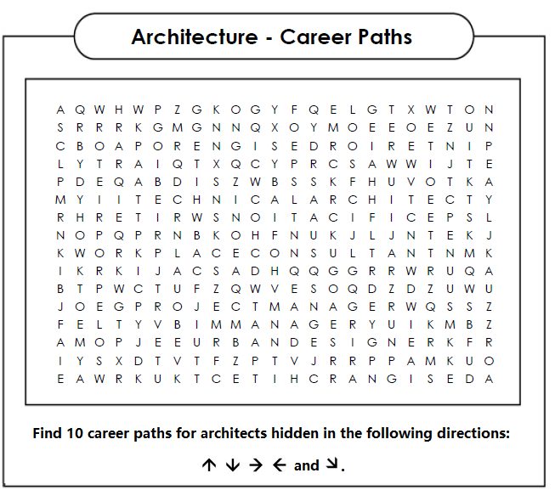

- Watch the video and answer the following questions:

  - What’s the difference between being a technical architect and a design architect?
…………………………………………………………………………………………..
…………………………………………………………………………………………..
…………………………………………………………………………………………..
  - What does being a BIM manager mean?
…………………………………………………………………………………………..
…………………………………………………………………………………………..
…………………………………………………………………………………………..
  - How can you describe the job of specifications writers?
…………………………………………………………………………………………..
…………………………………………………………………………………………..
  - What is a project manager responsible for?
…………………………………………………………………………………………..
…………………………………………………………………………………………..
  - What is an interior designer in charge of?
…………………………………………………………………………………………..
…………………………………………………………………………………………..
  - Why is the workplace consultant job different from others?
…………………………………………………………………………………………..
  - What requirement is essential to become a sustainability consultant?
…………………………………………………………………………………………..
…………………………………………………………………………………………..
  - What does an urban designer do?
…………………………………………………………………………………………..
…………………………………………………………………………………………..
  - How does a sole proprietor work?
…………………………………………………………………………………………..
…………………………………………………………………………………………..

- Oral Discussion:
  - Are career paths in Architecture similar in Mendoza? Compare similarities and differences according to each path.
  - Are there other possibilities that architects have after graduating in Mendoza? If so, which ones?

