Inglés Técnico
Revisión y práctica para primer parcial
- Traducir la oración y sus variantes
- There may always be special circumstances why corrosion does not occur when expected.
- There has always been
- There would be
- There must have been
- There were
- Being able to continuously tune both strain and twist angle will give researchers unprecedented access to the “phase diagram” of twisted angles.
- might give
- will have given
- could give

- Traducir las oraciones siguientes
- These electrodes intercept the neural signals that – had it not been for the stroke – would have activated muscles in her face, jaw, larynx and tongue.

- Scientists have been asked to develop zero-pollution firecrackers that do not cause health hazards to children.

- Projections by the US Energy Information Administration in 2016 estimated﻿ that shale gas would account for 30 per cent of world natural gas production by 2040.

- Should a bridge be the preferred solution for an additional or replacement crossing, models of suitable bridges would be tested in wind tunnel machines.

- The pressure of a given mass of gas is directly proportional to its absolute temperature, provided that its volume is kept constant.

- Polymer composite materials have been proven to have numerous electrical related applications ranging from energy storage to sensing, and 3D printing is a promising technique to fabricate such materials with a high degree of freedom and low lead up time.
C. Traducir el texto
RESEARCH UPDATE

Graphene ribbons advance twistronics
19 Sep 2023 Isabelle Dumé
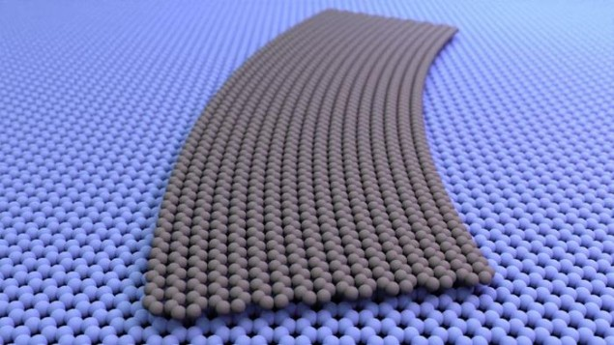On the curve: A curved graphene ribbon, illustrated in grey, shown laid flat against another graphene sheet. There is a continuous change in the twist angle between the ribbon above and the sheet below. In some places the atomic lattices of the two sheets line up at a 0° angle to each other, while in others, they are twisted relative to each other by as much as 5°. (Courtesy: Cory Dean, Columbia University)
Ribbons of graphene, rather than squares, could make a better platform for probing the unusual electronic effects that arise from twisting and straining adjacent layers of two-dimensional (2D) materials. This is the finding of scientists in the US, Denmark, France and Japan, whose approach differs significantly from previous “twistronics” studies that focused on twisting two flakes of material with respect to each other and then stacking them. According to the team, the new ribbon-based technique could give researchers better control over the twist angle, making the electronic effects easier to study.
In recent years, researchers have found that they can change the electronic properties of 2D materials by stacking layers of these materials atop each other and varying the angle between them. For instance, a bilayer of graphene does not normally have a band gap, but it develops one when placed in contact with another 2D material, hexagonal boron nitride (hBN).
This change occurs because the lattice constant of hBN – a measure of how its atoms are arranged – is nearly the same as that of graphene, but not quite. The slightly mismatched layers of graphene and hBN form a larger structure known as a moiré superlattice, and the interactions between nearby atoms in this superlattice allow a band gap to form. If the layers are then twisted so that they are further misaligned and the angle between them becomes large, the band gap disappears. Similarly, graphene on its own can be tuned from semi-metallic to semiconducting and even superconducting depending on the angle between the individual graphene layers.

