CRONOGRAMA
INGLES B2
10/9

24/9

1/10

8/10

15/10

22/10

29/10

5/11

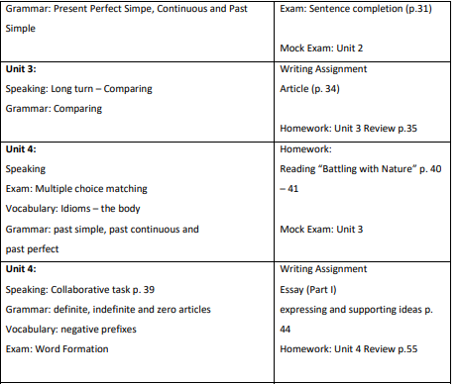
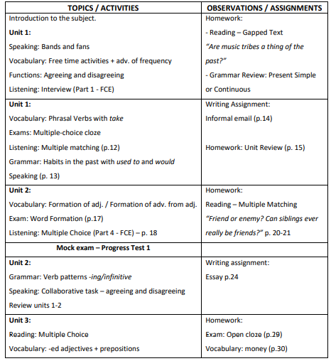

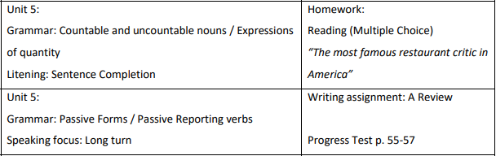
12/11

19/11

24/11
Final Revision (1 hour for English B2)

PROPÓSITOS ESPECÍFICOS
1 de Septiembre - Examen de ingreso
8 de Septiembre - Career Paths. Engineering. Book 1. What’s engineering?: Pages 4 and 5. //
Career Paths. Engineering. Book 2. Traits of an Engineer: Page 6.
15 de Septiembre – Career Paths. Engineering. Book 2. Traits of an Engineer: Page 7. // Career Paths. Engineering. Book 2. An Engineer’s Education: Page 8 and 9.
22 de Septiembre – Career Paths. Engineering. Book 1. Civil Engineering: Pages 24 and 25. // Career Paths. Engineering. Book 2. Industrial Engineering: Pages 28 and 29.
29 de Septiembre – Career Paths. Architecture. Book 2. Qualities of an Architect: Pages 4 and 5 // Career Paths. Architecture. Book 2. People in Architecture: Pages 6 and 7.
6 de Octubre - Career Paths. Architecture. Book 1. Education 1: Pages 30 and 31 // Career Paths. Architecture. Book 1. Education 2: Pages 32 and 33.
13 de Octubre - Career Paths. Engineering. Book 1. Working with Numbers: Pages 16 and 17. // Career Paths. Architecture. Book 1. Basic Maths: Pages 18 and 19.
20 de Octubre – Oral presentations
27 de Octubre - Career Paths. Engineering. Book 1. Problem Solving: Pages 12 and 13. // Career Paths. Engineering. Book 2. Presenting Information: Pages 10 and 11.
3 de Noviembre - Career Paths. Engineering. Book 1. Creativity. Pages 14 and 15.
10 de Noviembre - Career Paths. Architecture. Book 1: Parts of a Building 1 and 2: Pages 6, 7, 8 and 9.
17 de Noviembre - Career Paths. Architecture. Book 1. Describing Shapes and Structures: Pages 14 and 15. // Career Paths. Architecture. Book 1. Describing Landscapes: Pages 16 and 17.
24 de Noviembre – Final revision: 1 hour for specific purposes
EXAMEN FINAL: 26 DE NOVIEMBRE

